EE2026 Finance Bros Elaboration

This section is purely for anyone who wants a deeper understanding of our program and **does not have to be read.**

This section is to help better understand the flow of our program (as we feel it is quite complicated)

**It is possible to use the program & grade without reading this section**, but this would hopefully clarify any doubts.

# Architecture

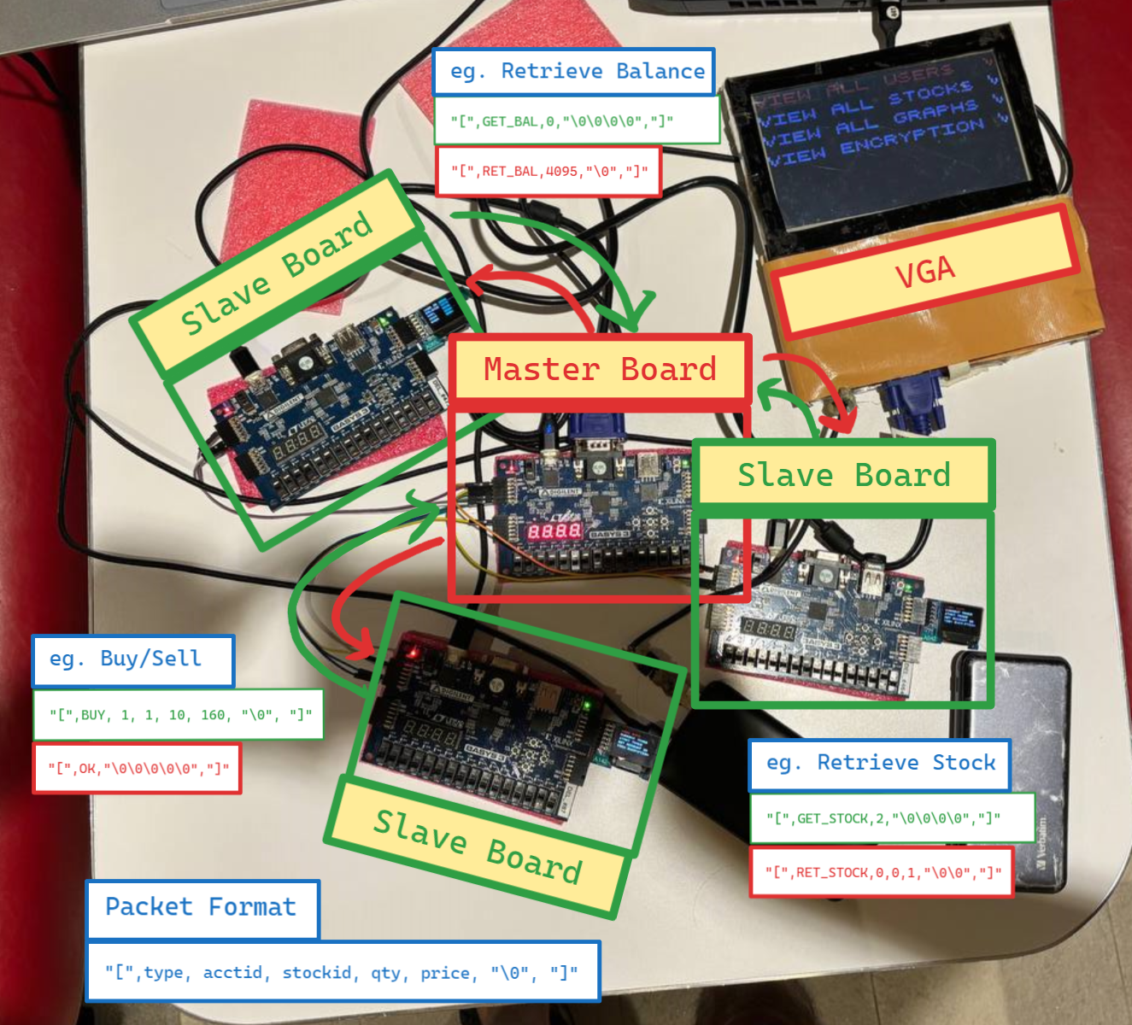

Pinouts: JA1, JA2 (rx0, tx0), JA3, JA4 (rx1, tx1), JA7,JA8(rx2, tx2)

rx0 and tx0 of the slave boards would connect to the tx<num> and rx<num> on the master board respectively. The boards would be grounded

OLED is connected to JB on all boards. VGA can be connected to any board for OLED mirroring, but should ideally be connected to the master board for displaying graphs

# Navigation

## Overview

| Name | Screen(s) | Controls |
| --- | --- | --- |
| Start Page |  | **sw[0]**: Master Mode  **sw[1]**: Trader/ Slave Mode  **sw[2]**: Money Simulation Mode  The switch with the lower number takes priority |
| VGA Display |  | **sw[3]**: Toggle VGA between Mirroring OLED & Displaying Graphs |

## Master Mode - **sw[0]**

| Name | Screen(s) | Controls |
| --- | --- | --- |
| Master Main Menu |  | **btnU/btnD**: Change Option  **btnC**: Select Option |
| Option 1 - Users Page |  | **btnL/R:** Cycle between users 0 to 2  **btnC**: Go Back |
| Option 2 - Stock Prices Page |  | **btnC**: Go Back |
| Option 3  - Graphs |  | **btnL/R:** Cycle between users 0 to 2, and show all graphs (with flickering)  **btnC**: Go Back  Mouse  **Mouse Cursor is a Purple Dot**  **Moving** the mouse cursor and **Right clicking** on any section in the graph would allow the display to zoom in. The zoom factor would follow the position of the mouse cursor.  **Left Click** would exit zoom  The zoomed view on the graph updates dynamically without the need to zoom out first. The frame adjusts instantly to the cursor's new position. |
| Option 4 - Encryption |  | **btnC**: Go Back |

## Slave Mode - **sw[1]**

| Name | Screen(s) | Controls |
| --- | --- | --- |
| Master Main Menu |  | **btnU/btnD**: Change Option  **btnC**: Select Option |
| Option 1 - Getting User Info |  | **btnL:** Force Exit  **btnC**: Go Back (After Info has loaded) |
| Option 2 - Current Trade |  | **btnC**: Go Back |
| Option 3 - Start Trade |  | **OLED/ 7 Segment:** Display Numerical Value  **btnU/D:** Increase/ Decrease Numbers  **sw[15]**: Increase by 1000  **sw[14]**: Increase by 100  **sw[13]**: Increase by 10  **else**: Increase by 1  **btnL/R**: Change between Buy and Sell  **btnC**: Go Back |
| Option 4 - Set Account ID |  | **OLED/ 7 Segment:** Display Numerical Value  **btnU/D:** Increase/ Decrease Numbers  **btnC**: Go Back |
| Option 5 - Encryption |  | **btnC**: Go Back |
| Green Screen |  | **Showed when a buy/sell operation is successful**  If it is not successful, the operation would keep being sent |

## Animation - **sw[2]**

| Name | Screen(s) | Controls |
| --- | --- | --- |
| Money Simulation |  | **btnL, btnR**: Rotate left and right  **btnU, btnD**: Move forward and back  **btnC**: Hide money bills (why would you do it?) |